Physical layer and Media Pt2 –

Digital signal – Digital signal is the type of signal which can take finite values in a period of time.

In case of digital signal, the time as well as magnitude is been taken into consideration.

Physical media –

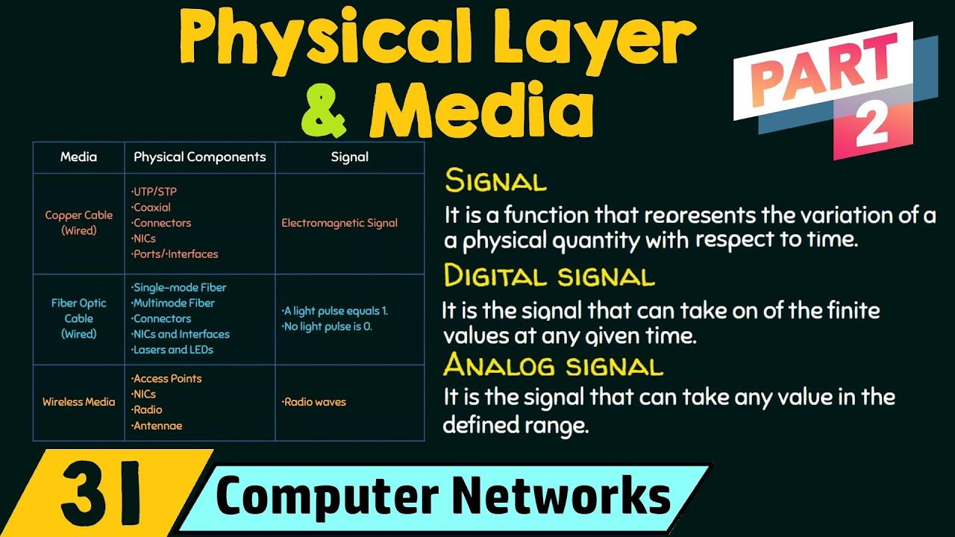

1. Wired media -
2. Copper cable - Electromagnetic Signal -

Physical Components –

UTP /STP (Untwisted pair / twisted pair cable) by rj45 port

Coaxial cable – mic set, set top box connector to dish antenna

NICs – network Interface cards.

Ports / interfaces.

Connectors.

2. Fiber Optic Cable - Light pulse = 1 and No light pulse = 0 -

Physical Components –

Single mode fiber - Single straight path for the light pulse.

Multi mode fiber – multiple paths for the light pulses.

Lasers and LEDs.

NICs – network Interface cards.

Ports / interfaces.

1. Wireless media – radio Waves -

Physical components –

Access Points Wi-Fi can be an Access points

NICs.

Radio.

Antennae. – To generate and catch radio waves.